Assignment 17.2

Problem Statement 1:

1. Read the text file, and create a tupled rdd.

Dataset in a text file:

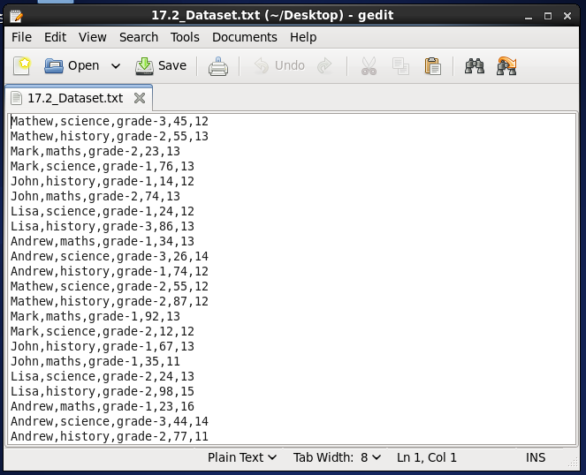

Creating a tuple rdd:

Tuple rdd created:

2. Find the count of total number of rows present.

In a text file, row count is 22,

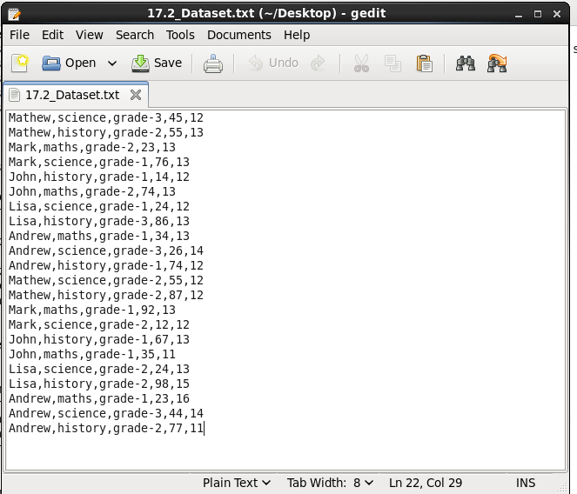

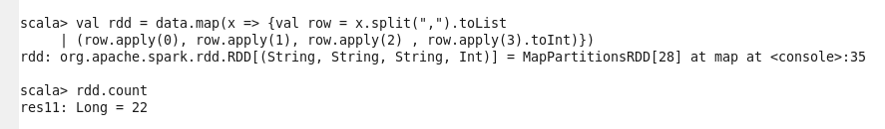

3. What is the distinct number of subjects present in the entire school

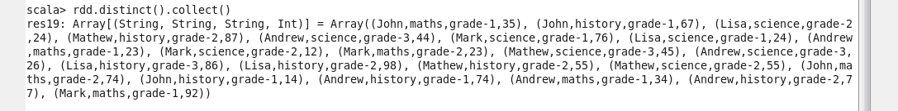

4. What is the count of the number of students in the school, whose name is Mathew and
marks is 55

